Code.

# Change link address to your address.

X15387_copy_of_dataset_excel <- read_excel("C:/Users/./Downloads/15387_copy_of_dataset__excel.xls")

vissR <- X15387_copy_of_dataset_excel

attach(vissR)

#Histogram

hist(jobsat, main = " Distrubution of Job Satisfaction 'Degree'",breaks = 5,col = "chartreuse3", las = 1)

#Bar chart plot

M = c("High School Graduate","Associates Degree","Bachelors Degree","Masters Degree")

education <- factor(education,levels = M )

frequencies <- table(education)

cols = c("aquamarine1","aquamarine2","aquamarine3","aquamarine4")

barplot(frequencies, main = "Education classes and their frequencies",xlab = "class of Education",ylab = "Number",las = 1, names.arg = c("HSG","AD","BD","MD"), col = cols, legend.text = c("High School graduates","Associate Degree","Bachelors degree","Masters degree"))

boxplot(skill, las = 1, main = "Skill Degree Spread", col ='azure')

qqnorm(orgcom,main = "Orgcom Quantile quantile plot", las = 1, pch = 19)

qqline(orgcom, col ="red")

1. **Histogram**

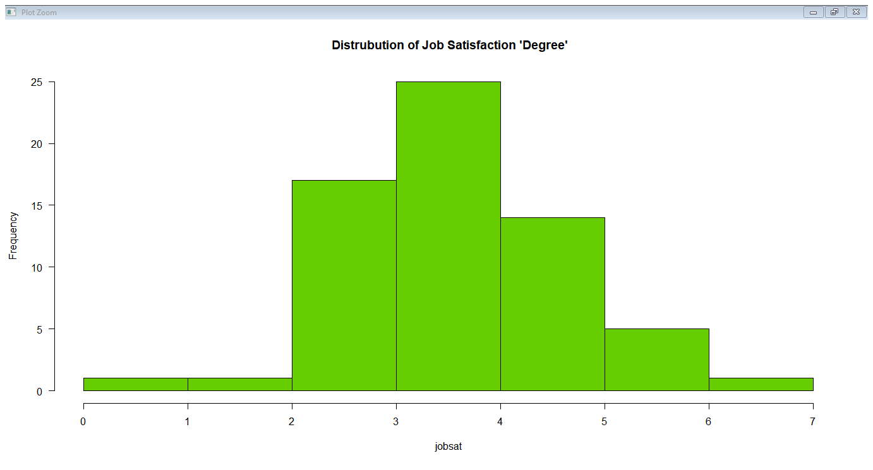

2.)**Bar Chart**

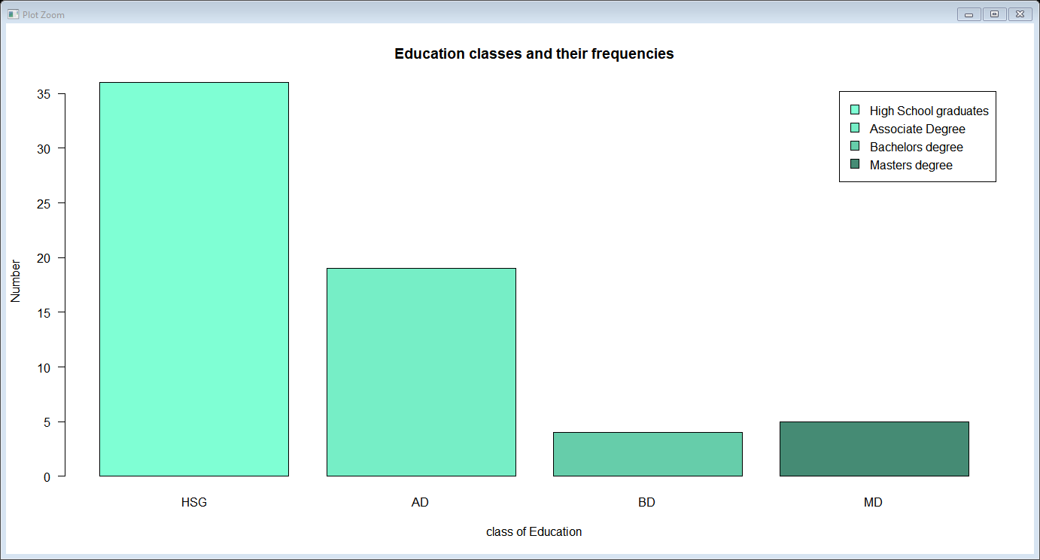

3.) **Boxplot**

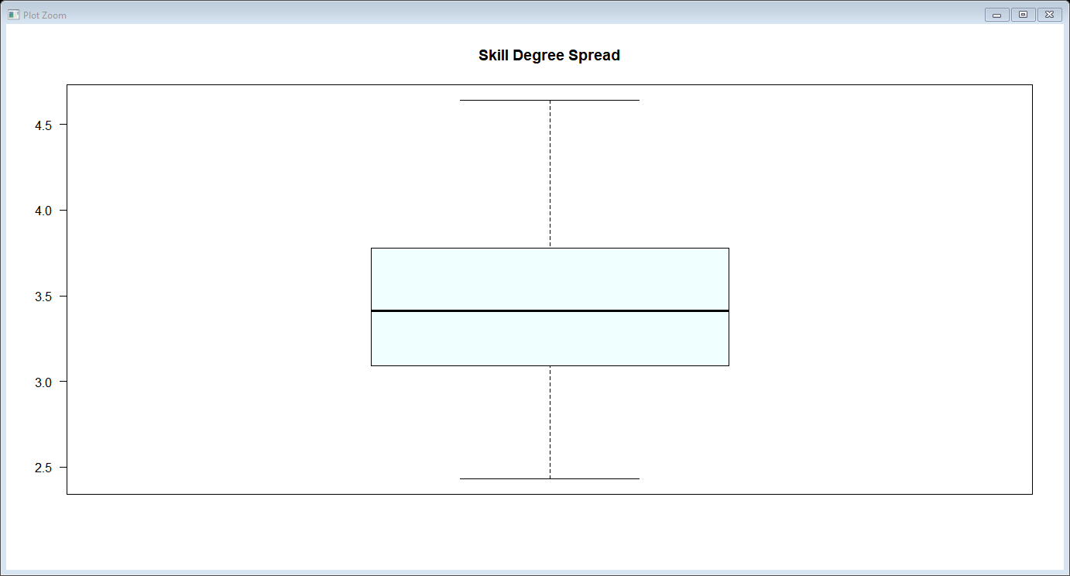

4. **Comparing Quantiles to those of the Normal Distribution**

